Deep Learning
Name: P. Lakshmi Gayathri Navaneetha
Reg No:192321169
EXPERIMENT 1: Vector and Matrix Operations for Deep Learning
Aim:
To perform vector and matrix operations using NumPy and visualize the results using Matplotlib.
Algorithm:
- Import NumPy and Matplotlib libraries.
- Create two vectors using NumPy arrays.
- Perform vector addition, subtraction, and dot product.
- Create two matrices and perform addition and multiplication.
- Plot the vectors using Matplotlib.
- Save the graph as an image.
- Display the results.
Code:
import numpy as np
import matplotlib
matplotlib.use("Agg")
import matplotlib.pyplot as plt

a = np.array([2, 4, 6])
b = np.array([1, 3, 5])

print("Vector Addition:", a + b)
print("Vector Subtraction:", a - b)
print("Dot Product:", np.dot(a, b))

A = np.array([[1, 2], [3, 4]])
B = np.array([[5, 6], [7, 8]])

print("Matrix Addition:\n", A + B)
print("Matrix Multiplication:\n", np.dot(A, B))

plt.plot(a, marker="o", label="Vector A")
plt.plot(b, marker="s", label="Vector B")
plt.title("Vector Operations")
plt.xlabel("Index")
plt.ylabel("Value")
plt.legend()
plt.grid(True)
plt.savefig("experiment1.png")
plt.close()
output:
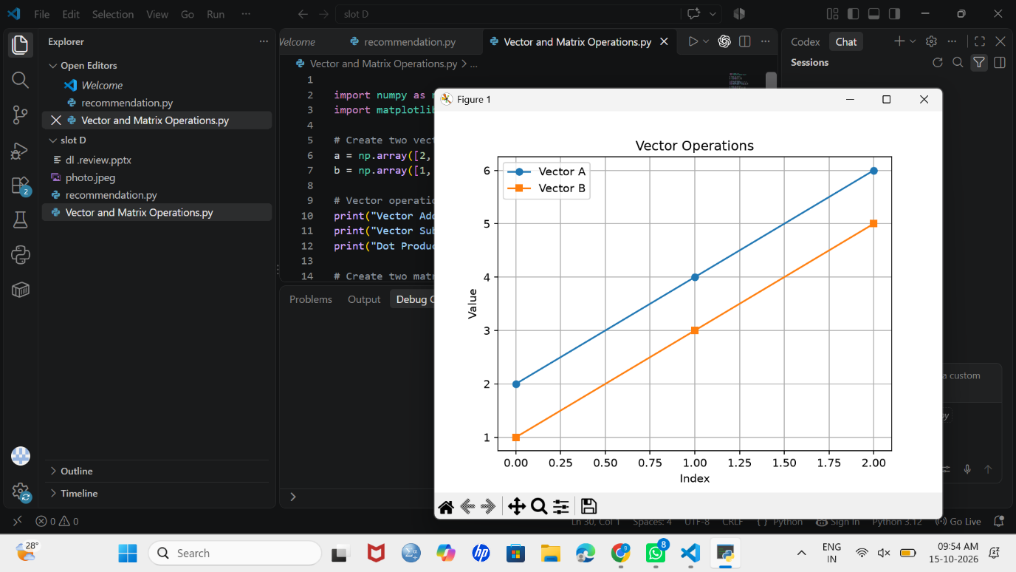
Result:
Vector and matrix operations were performed successfully using NumPy, and the graph was saved using Matplotlib.

EXPERIMENT 2: Covariance, Eigenvalues and Eigenvectors Analysis
Aim:
To calculate the covariance matrix, eigenvalues, and eigenvectors of a dataset using NumPy and Pandas and visualize the data using Matplotlib.
Algorithm:
- Import NumPy, Pandas, and Matplotlib libraries.
- Create a dataset containing study hours and marks.
- Convert the dataset into a Pandas DataFrame.
- Calculate the covariance matrix.
- Calculate the eigenvalues and eigenvectors using NumPy.
- Plot the relationship between study hours and marks.
- Save the graph and display the results.
Code:
import numpy as np
import pandas as pd
import matplotlib
matplotlib.use("Agg")
import matplotlib.pyplot as plt

data = {
"Hours": [1, 2, 3, 4, 5],
"Marks": [10, 20, 30, 40, 50]
}

df = pd.DataFrame(data)
print("Dataset:\n", df)

cov_matrix = df.cov()
print("Covariance Matrix:\n", cov_matrix)

eigenvalues, eigenvectors = np.linalg.eig(
cov_matrix.to_numpy()
)

print("Eigenvalues:\n", eigenvalues)
print("Eigenvectors:\n", eigenvectors)

plt.scatter(df["Hours"], df["Marks"])
plt.plot(df["Hours"], df["Marks"])
plt.title("Hours Studied vs Marks")
plt.xlabel("Hours Studied")
plt.ylabel("Marks")
plt.grid(True)
plt.savefig("experiment2.png")
plt.close()
output:
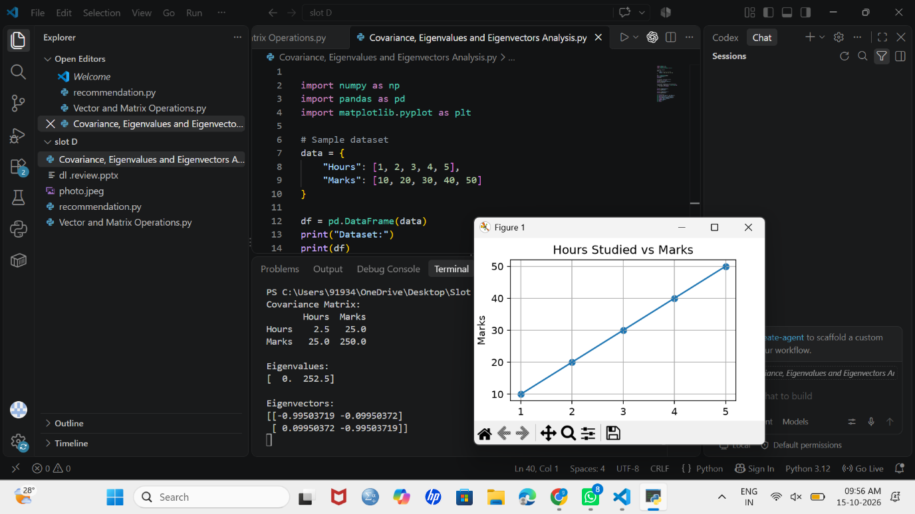
Result:
The covariance matrix, eigenvalues, and eigenvectors were calculated successfully, and the relationship between study hours and marks was visualized.
EXPERIMENT 3: Probability Distributions and Bayes’ Theorem
Aim:
To calculate probability distributions and apply Bayes’ theorem using NumPy and SciPy and visualize the probability distribution using Matplotlib.
Algorithm:
- Import NumPy, SciPy, and Matplotlib libraries.
- Define the number of trials and probability of success.
- Calculate binomial probabilities using SciPy.
- Define the probabilities required for Bayes’ theorem.
- Calculate the probability of a positive test result.
- Apply Bayes’ theorem to calculate the probability of disease given a positive result.
- Plot the binomial distribution and save the graph.
- Display the results.
Code:
import numpy as np
import matplotlib
matplotlib.use("Agg")
import matplotlib.pyplot as plt
from scipy.stats import binom

n = 10
p = 0.5

x = np.arange(0, n + 1)
probabilities = binom.pmf(x, n, p)

print("Binomial Probability Distribution:")
for i in range(len(x)):
print(f"P(X={x[i]}) = {probabilities[i]:.4f}")

p_disease = 0.01
p_positive_given_disease = 0.90
p_positive_given_no_disease = 0.05
p_positive = (
p_positive_given_disease * p_disease
+ p_positive_given_no_disease * (1 - p_disease)
)
p_disease_given_positive = (
p_positive_given_disease * p_disease / p_positive
)

print("P(Disease | Positive) =",
round(p_disease_given_positive, 4))

plt.bar(x, probabilities)
plt.title("Binomial Probability Distribution")
plt.xlabel("Number of Successes")
plt.ylabel("Probability")
plt.grid(axis="y")
plt.savefig("experiment3.png")
plt.close()
output:
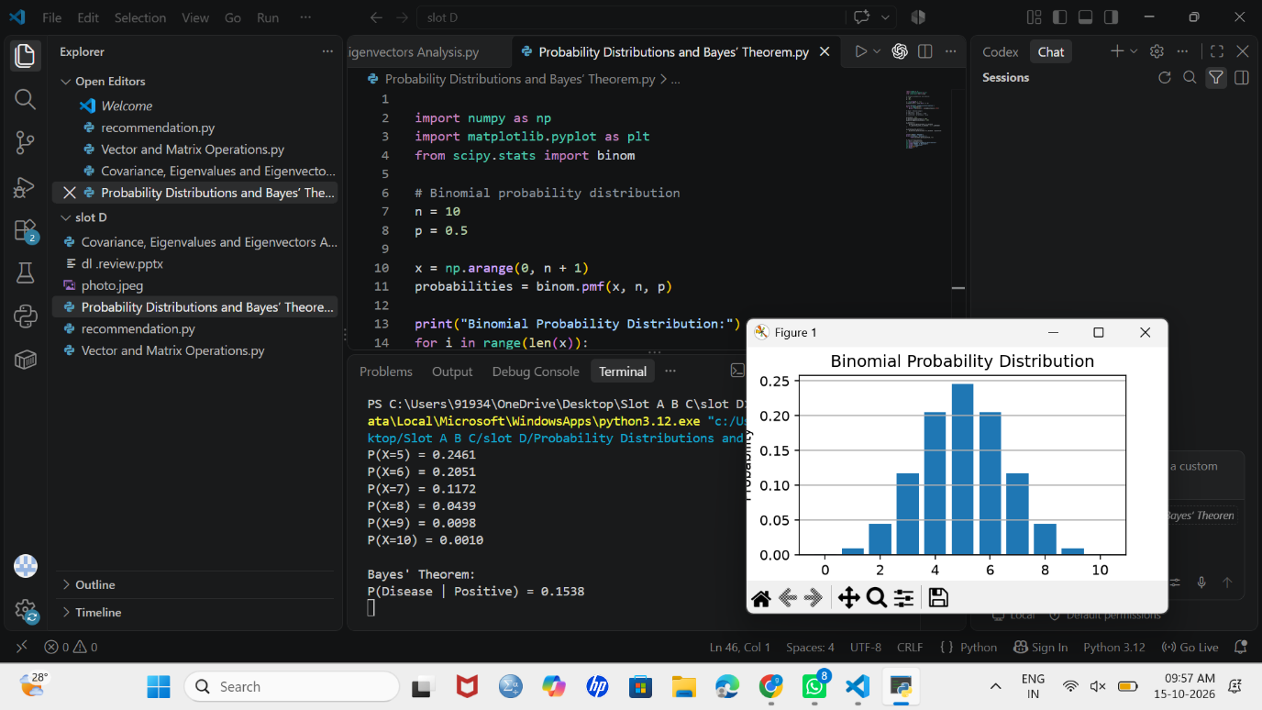
Result:
The binomial probability distribution was calculated successfully, Bayes’ theorem was applied, and the probability distribution graph was saved.
EXPERIMENT 4: Entropy, Cross-Entropy and KL Divergence
Aim:
To calculate entropy, cross-entropy, and Kullback–Leibler (KL) divergence between
probability distributions using NumPy and SciPy and visualize the results using Matplotlib.

Algorithm:
- Import NumPy, SciPy, and Matplotlib libraries.
- Define the actual and predicted probability distributions.
- Calculate entropy using SciPy.
- Calculate cross-entropy using NumPy.
- Calculate KL divergence using SciPy.
- Plot the actual and predicted probability distributions.
- Save the graph and display the results.
Code:
import numpy as np
import matplotlib
matplotlib.use("Agg")
import matplotlib.pyplot as plt
from scipy.stats import entropy

P = np.array([0.7, 0.3])
Q = np.array([0.5, 0.5])

H_P = entropy(P)
cross_entropy = -np.sum(P * np.log(Q))
kl_divergence = entropy(P, Q)

print("Entropy:", round(H_P, 4))
print("Cross-Entropy:", round(cross_entropy, 4))
print("KL Divergence:", round(kl_divergence, 4))

labels = ["Class 1", "Class 2"]
x = np.arange(len(labels))
width = 0.35
plt.bar(x - width / 2, P, width, label="Actual P")
plt.bar(x + width / 2, Q, width, label="Predicted Q")
plt.title("Actual vs Predicted Probabilities")
plt.xlabel("Classes")
plt.ylabel("Probability")
plt.xticks(x, labels)
plt.legend()
plt.grid(axis="y")
plt.savefig("experiment4.png")
plt.close()
output:
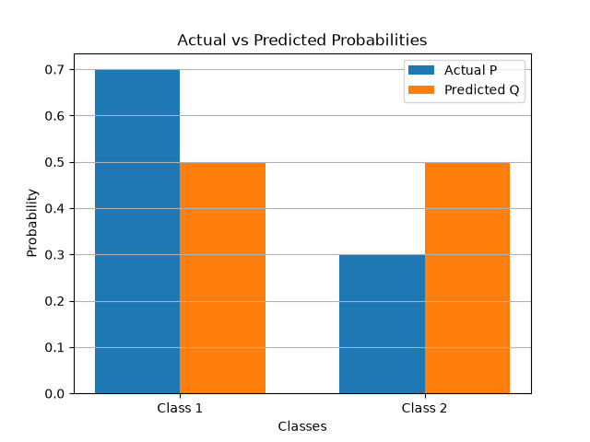
Result:
Entropy, cross-entropy, and KL divergence were calculated successfully, and the actual and predicted probability distributions were visualized and saved as a graph.

